**Read me guide**

**Pre-requisites:**

* **Step 1:**  You need an AWS account with Administrator access for successfully completing the workshop. If you do not have one, you can create an AWS account. For instructions on how to create an account, see following page**-** [**https://aws.amazon.com/premiumsupport/knowledge-center/create-and-activate-aws-account/**](https://aws.amazon.com/premiumsupport/knowledge-center/create-and-activate-aws-account/)

*(We will provide you credits when you register at the day of boot camp for your AWS usage during boot camp)*

* **Step 2:** Set up the lab environment in your AWS account that you intend to use for the workshop.

**Files provided to you**:

The email provided to you contains following files:

* This read me guide which contains pre-requisites and lab environment set up instructions(Read me guide – Toronto Bootcamp.docx).
* A CloudFormation template file (lab.template)
* Individual instruction document (individual_lab.pdf)
* A Group lab-instruction document (Group lab - SelfserviceIncidentManagement.pdf)

Before coming for the workshop you would need to set up the environment using lab.template. To do so, follow following steps.

**lab environment set up instructions:**

1. Login to you your test AWS account as an administrator. **Note** - Ensure that you have **AdministratorAccess** policy attached with your login as you would be creating AWS resources including IAM roles and users.
2. Next, you need to run a Cloudformation template. To do so, navigate to the service by opening following link in a browser window - <https://console.aws.amazon.com/cloudformation/home?region=us-east-1>
3. Choose "**Create Stack**" button.
4. Under "**Choose a template**", choose "**Upload a template to Amazon S3**" and then click on "**choose file**".
5. Specify the CloudFormation template(lab.template) you downloaded earlier.
6. Specify a **Stack name** as - ***SC-SNOW-<your-name>*** and then click **next**. Do not change the parameter value.
7. On **options** page, choose **next**,
8. On **Review** page, choose "I acknowledge that AWS CloudFormation might create IAM resources with custom names." checkbox and then choose **Create.**
9. Once status of the stack changes to **CREATE COMPLETE**, choose the stack and open the outputs tab to see the output:

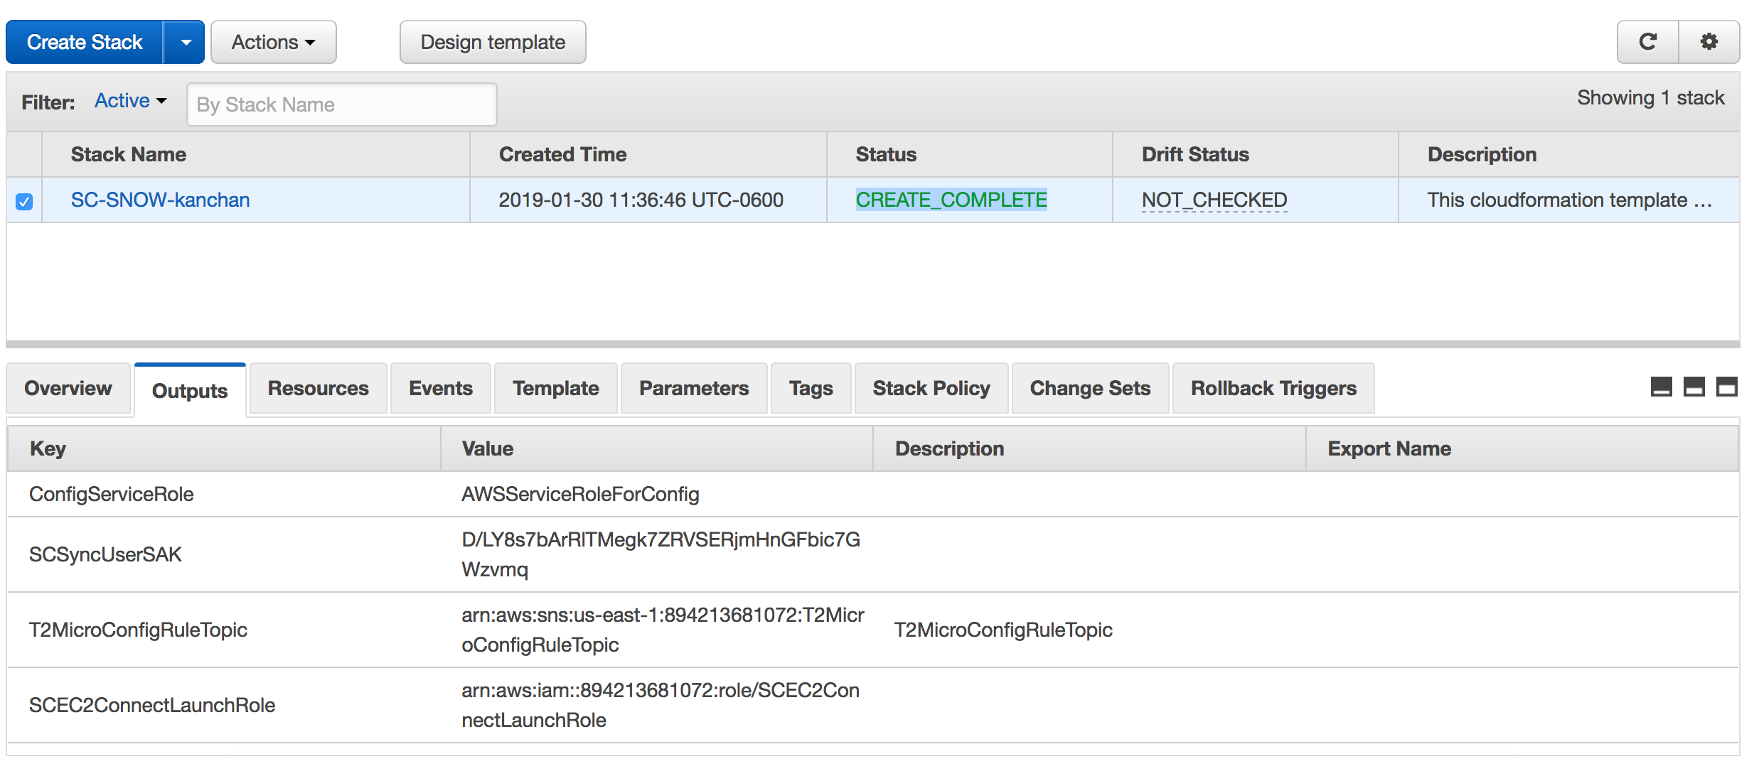

1. Copy the **key** and **value** column contents of the outputs section and save it in a text file – you would be referring to these output values throughout the lab. Here are the keys that you will find in the output.

|  |  |
| --- | --- |
| **ConfigServiceRole** |  |
| **SCSyncUserSAK** |  |
| **T2MicroConfigRuleTopic** |  |
| **SCEC2ConnectLaunchRole** |  |
| **SCEndUserSAK** |  |
| **SwitchRoleSCEndUser** |  |
| **SecurityGroup** |  |
| **SwitchRoleSCAdmin** |  |
| **PublicSubnetId** |  |
| **SCWorkspacesConnectLaunchRole** |  |
| **Region** |  |
| **SnowEndUser** |  |
| **ConfigBucket** |  |
| **MySimpleAD** |  |
| **AMI** |  |
| **ScheduledRule** |  |
| **SCSyncUserAccessKey** |  |
| **SCEndUserAccessKey** |  |